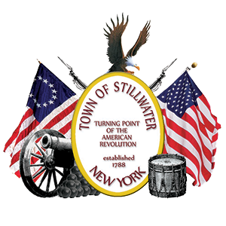

**Stillwater Town Board Meeting**

**Thursday, August 15th, 2024 ~ 7:00pm**

**Stillwater Town Hall**

Agenda Highlights

(Subject to Changes as needed)

**TOWN BOARD MEETING**

**August 15, 2024**

Resolution No. 41 A Resolution to Increase Water Rates

Resolution No. 42 Budget Adjustments and Transfers

Resolution No. 43 LaBella Engagement Agreement for Water District # 7

Resolution No. 44 Authorizing Court Grant Application

Resolution No. 45 Highway Superintendent Resignation and Appointment

Resolution No. 46 Advertise for Bids for Highway Equipment

Resolution No. 47 Awarding Bid for Highway Equipment

PUBLIC HEARINGS/LOCAL LAWS

(None)

BIDS FOR OPENING

1. Highway Equipment